Order Of Service

Singing: Psalm 32—CW page 78

Reading: Psalm 78:1-8

Opening Hymn: TLH 2

Reading: Acts 10:34-48

Request Hymn: CW Supplement 716

Reading: John 20:11-18

Sermon Hymn: TLH 605

Sermon Text: Daniel 6:10-13

The Trap Is Sprung

Prayer

The Apostles’ Creed, TLH page 12

Holy Communion

The Lord's Prayer

The Blessing

Closing Hymn: TLH 45

* * * * * * * * * * *

Bible Study: Lambs: Frog
Sheep: Romans 12:1-8
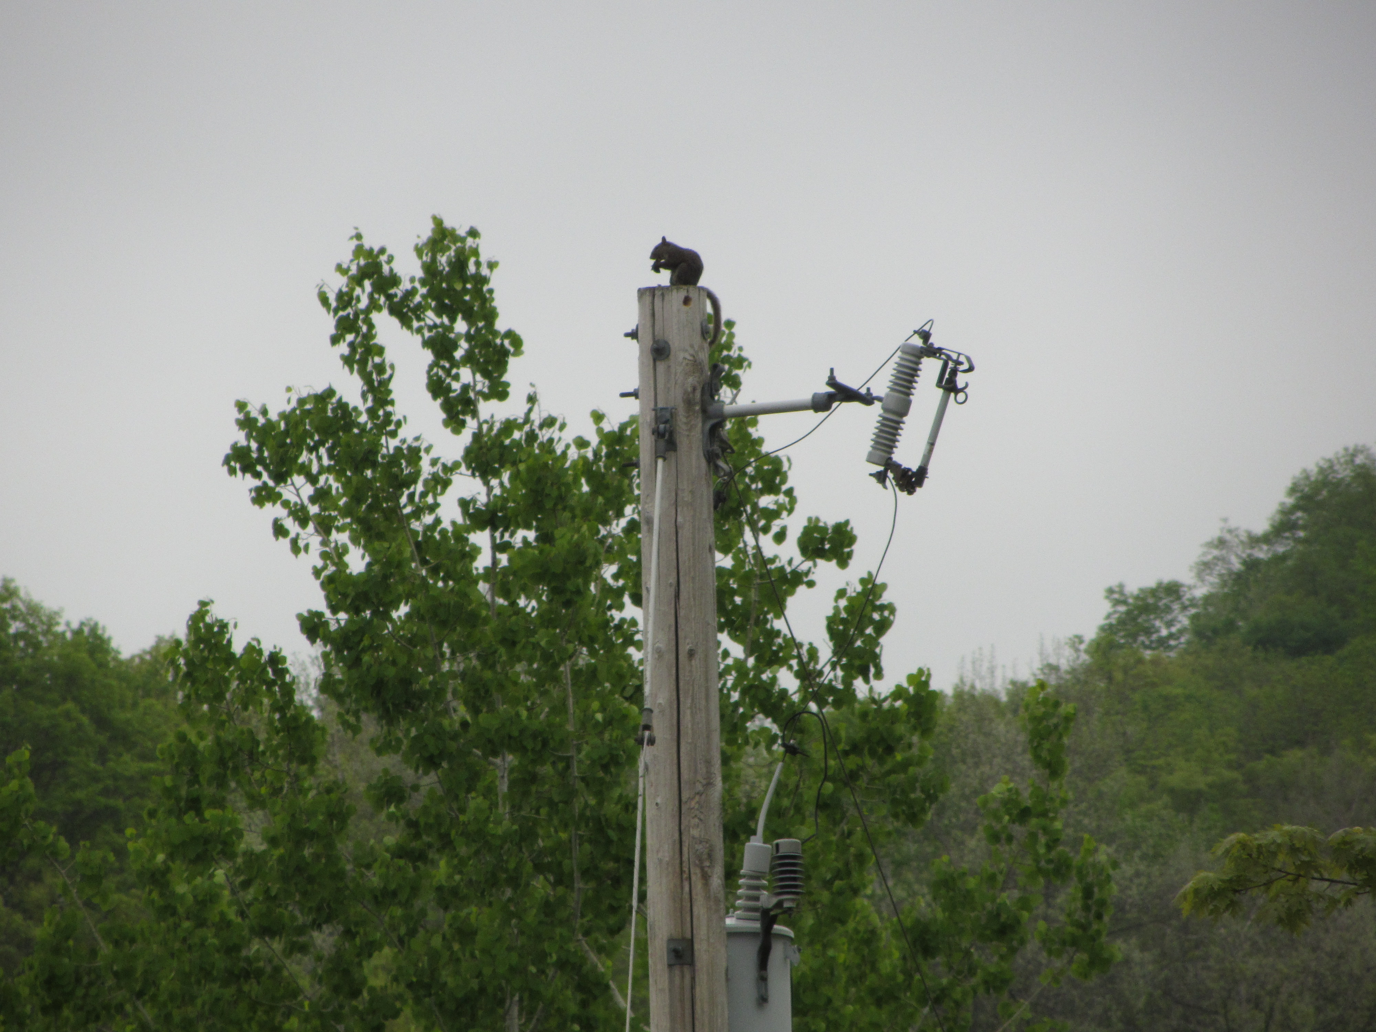

What A View !!!

Water
Of
Life

17 June 2018

W A T E R O F L I F E

Independent Christian Church—Conservative Lutheran Doctrine

Worship Service: 9:30 a.m. Bible Study: 10:45 a.m.

Larry Cooper, Pastor E-Mail address:
111 N. Ridge Road lcooper@wateroflife.cc
Coon Valley, WI 54623 Web Site:
Phone: (608) 452-2105 www.wateroflife.cc

* * * * * * * * * * * * * * * * * * * * * * * * * * *

Sermon Text: Daniel 6:10-13

The Trap Is Sprung

* * * * * * * * * * * * * * * * * * * * * * * * * * *

Daniel 6:10 Now when Daniel knew that the writing was signed, he went into his house; and his windows being open in his chamber toward Jerusalem, he kneeled upon his knees three times a day, and prayed, and gave thanks before his God, as he did aforetime.
:11 Then these men assembled, and found Daniel praying and making supplication before his God.
:12 Then they came near, and spake before the king concerning the king's decree; Hast thou not signed a decree, that every man that shall ask a petition of any God or man within thirty days, save of thee, O king, shall be cast into the den of lions? The king answered and said, The thing is true, according to the law of the Medes and Persians, which altereth not.
:13 Then answered they and said before the king, That Daniel, which is of the children of the captivity of Judah, regardeth not thee, O king, nor the decree that thou hast signed, but maketh his petition three times a day.

